Seatwork: **Probability**

Submitted by: Ethan Chav Isaac P. Sumalinog

Submitted to: Rubelito Abella

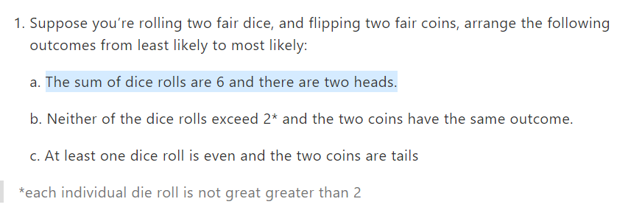

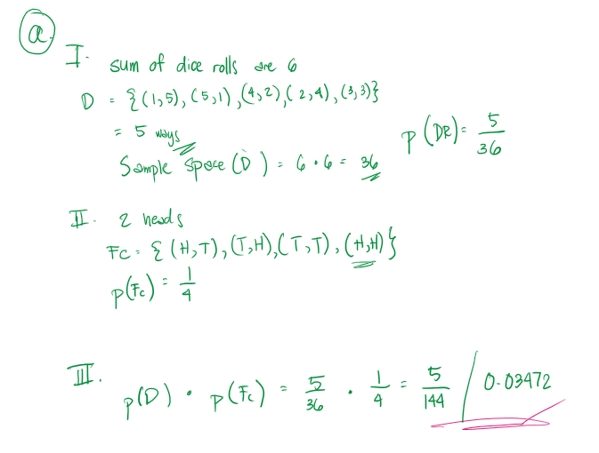

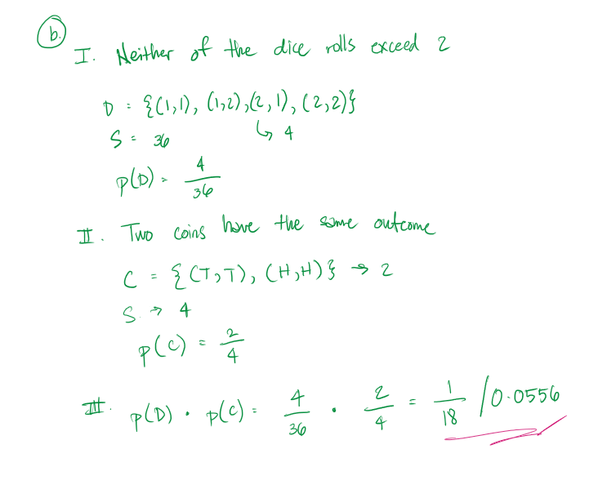

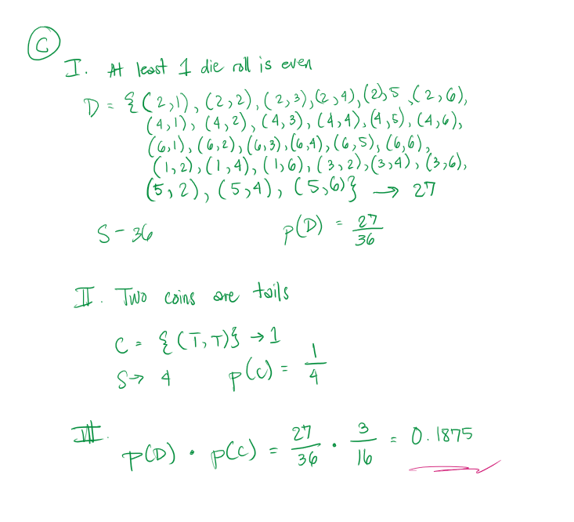

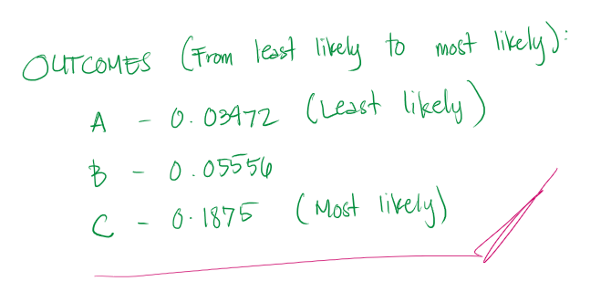

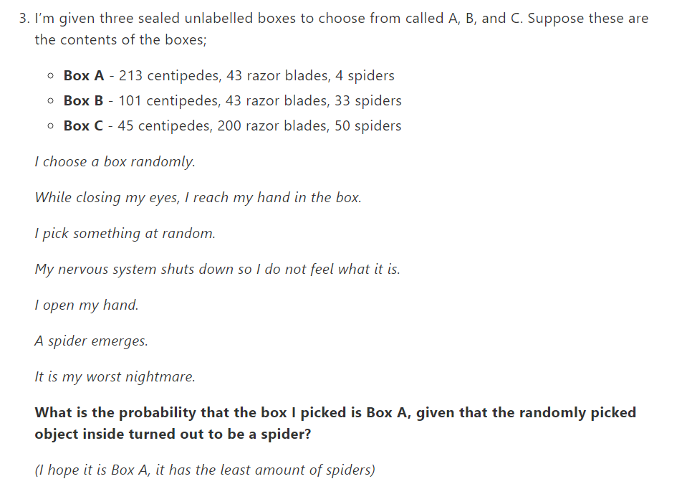

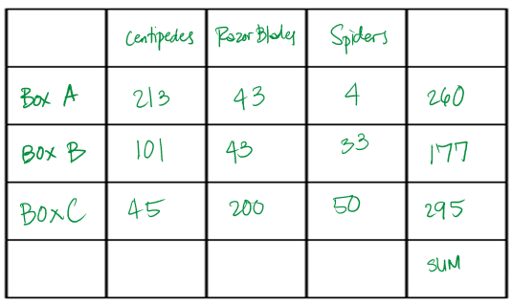

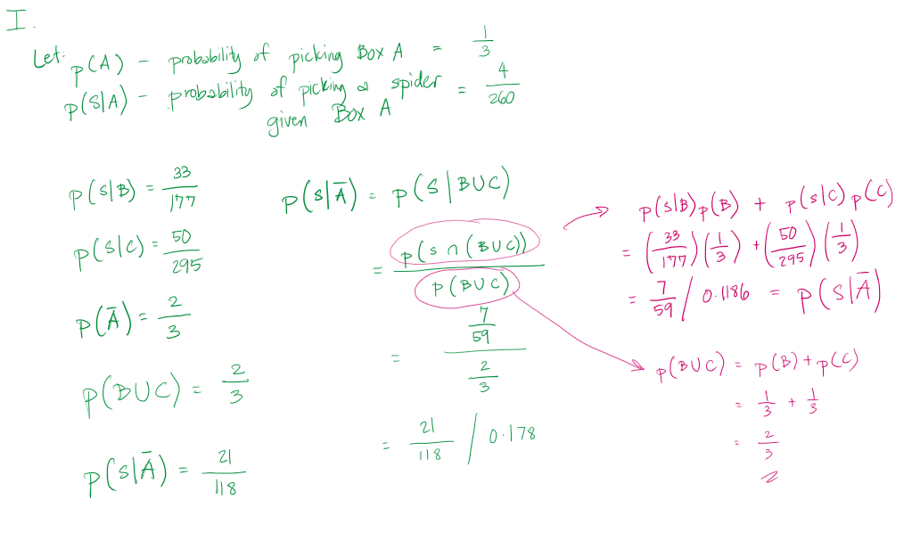

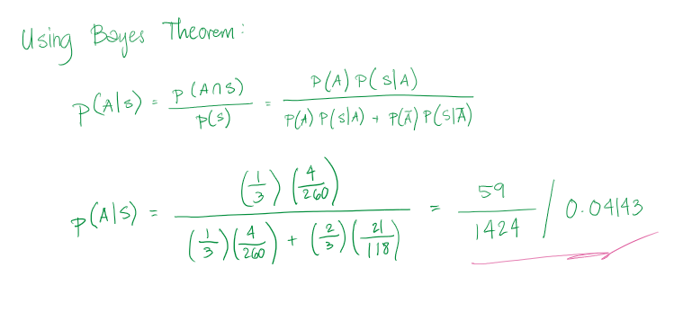

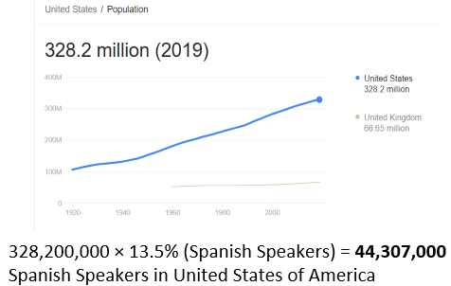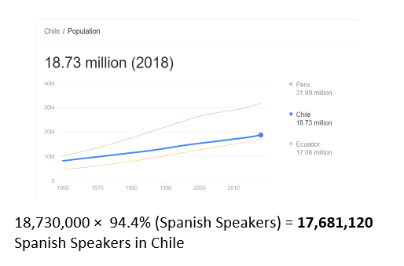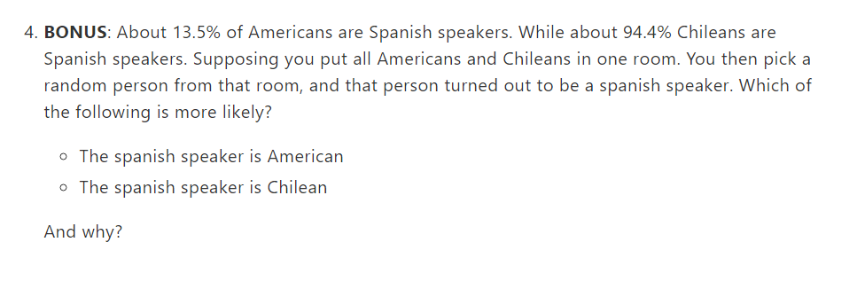

The data we have give us that there are the American population far exceeds the Chilean. After the computation of the percentage of Spanish speakers, we have **17,681,120** Spanish Speakers in Chile while **44,307,000** Spanish Speakers in United States of America. With the given data, it's most likely that it would be that the Spanish speaker is American.

Sources: Google, World Bank, United States Census Bureau, Eurostat